JECRC
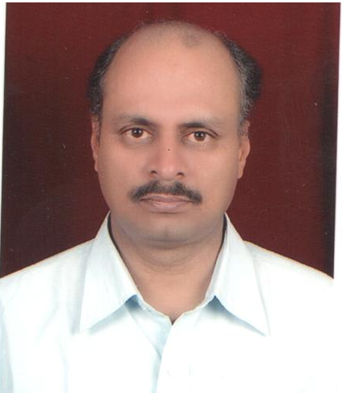Attest
passport
size photograph
JAIPUR

INDIVIDUAL FACULTY DATA SHEET
Name of the faculty member | : | Atul Kulshrestha
Present Designation | : | Assistant Professor
Email Id : atulkulshrestha.ee@jecrc.ac.in
Contact Details : 9414753167

I. Particulars of Educational Qualification: (only completed)

Category | Name of the Degree | Specialization | Year of Passing | Name of the College | Name of the University
UG | B.Tech | Electrical Engineering | 1990 | KNIT,Sultanpur (UP) | Awadh University
PG | M.Tech. | Power System | 2011 | MNIT, Jaipur | MNIT, Jaipur
Ph.D. | - | - | - | - | -

II. Academic Experience : 11 Years

III. Industrial Experience : 17 Years

IV. Title of Ph.D. Thesis : NA

V. Awards/Achievements : Accredited Energy Auditor by BEE

VI. Research/Specialization : (1) Presented paper in National Conference ETA-2010 organized in B.M.I.T. Jaipur on ‘SKY WIND MILL
(2) Presented paper in National Conference RTDEEE-2016 organized in JECRC Jaipur on ‘Enhancement of power system Reliability using DPFC” on 12-13 aug, 2016 published in ISSN 0976-7363

(3) Presented paper in International Conference RTDEEE-2018 organized in JECRC Jaipur on ‘A Review of Micro-grid structure and issues.

VII. Course Taught : Circuit Analysis
Generation of Electrical Power
Electrical Machine
Power system Instrumentation
Extra High Voltage AC/DC Transmission
Electric Drive and control.
High Voltage Engineering.
Control system
Utilization of Electrical Power

VIII. Refereed International Journal Publication : (1) Presented paper in National Conference RTDEEE-2016 organized in JECRC Jaipur on ‘Enhancement of power system Reliability using DPFC” on 12-13 aug, 2016 published in ISSN 0976-7363

(2) Presented paper in International Conference RTDEEE-2018 organized in JECRC Jaipur on ‘A Review of Micro-grid structure and issues.

IX. International Conference Proceeding : (1)Presented paper in National Conference RTDEEE-2016 organized in JECRC Jaipur on ‘Enhancement of power system Reliability using DPFC” on 12-13 aug, 2016 published in ISSN 0976-7363

(2) Presented paper in International Conference RTDEEE-2018 organized in JECRC Jaipur on ‘A Review of Micro-grid structure and issues.

X. Books Written : NIL

XI. M.Tech Thesis Guide : Mrs. Nikita Jhajharia

XII. PHD Thesis Guide : Nil

XIII. Professional Body Membership : Membersip No. IETE Society

